Database and Table Creation:
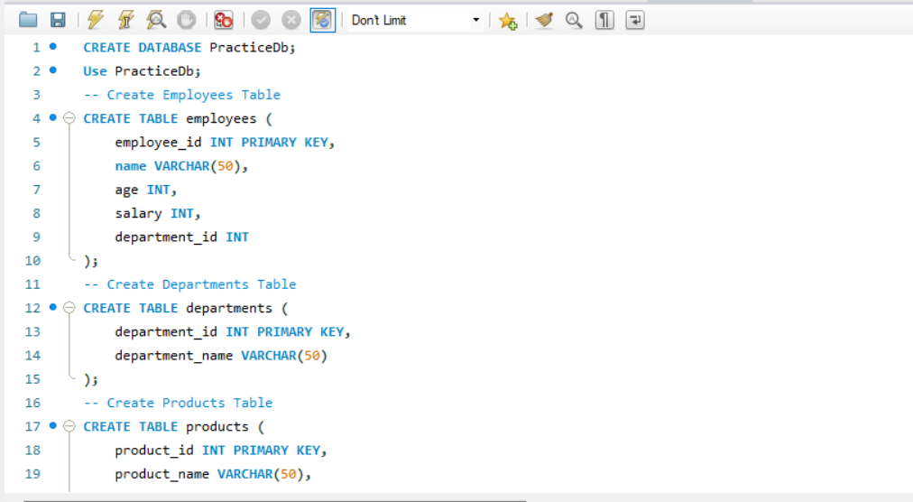
DATA INSERTION:
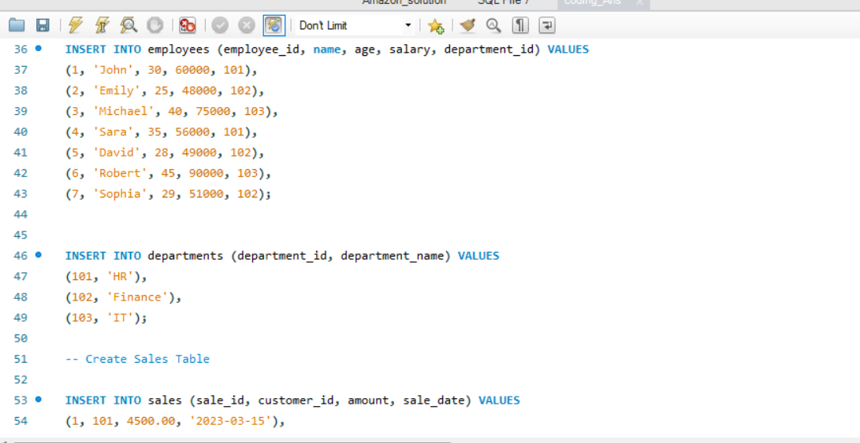

-- Question 1: Retrieve Employee Details
Retrieve all employees whose salary is greater than 60000.
SELECT name FROM employees
WHERE salary > 60000;
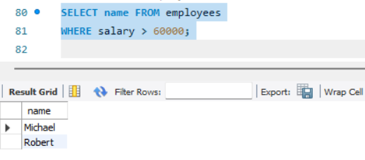
-- Question 2: Find Total Sales Per Customer
Calculate the total sales amount for each customer from the sales table.
SELECT customer_id, SUM(amount)
AS total_sales FROM sales
GROUP BY customer_id;
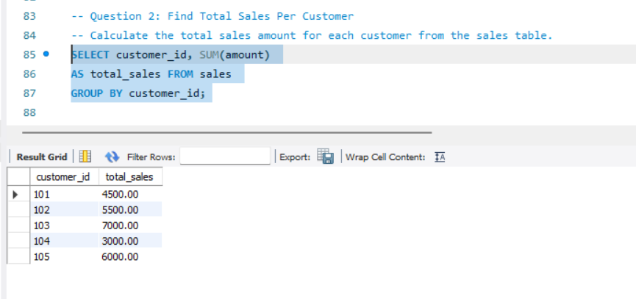

-- Question 3: Employee Salary in Finance Department
Retrieve the names and salaries of all employees working in the 'Finance' department.
SELECT e.name, e.salary FROM
employees e JOIN departments d
ON e.department_id=d.department_id
WHERE department_name='Finance';

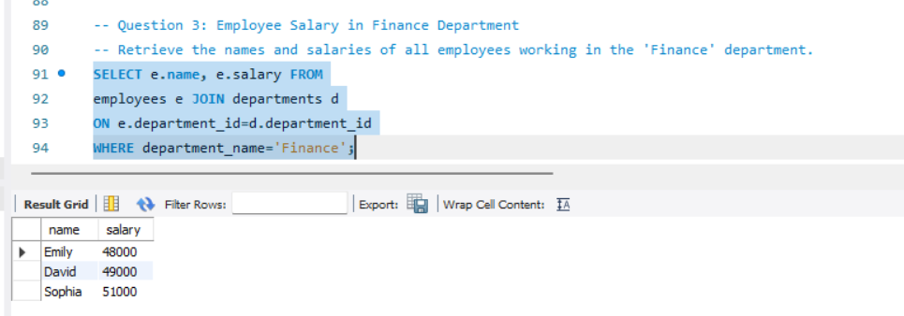

-- Question 4: Total Sales on a Specific Date
Find the total sales amount made on '2023-03-17'.
SELECT sale_date, sum(amount) FROM sales
sales WHERE sale_date='2023-03-17'
GROUP BY sale_date;
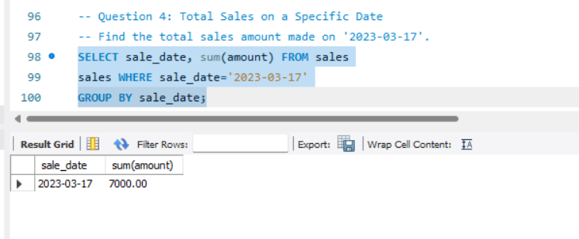
-- Question 5: High-Value Orders
Get the names of customers who have placed an order of more than 600.
SELECT customer_name FROM orders
WHERE order_amount>600;
